*ABSTRACT*

Music Recommendation Based on Facial Emotion Recognition

|  |  |  |
| --- | --- | --- |
| Dr. I Karthiga Department of Computer Science and Engineering Assistant Professorkarthiga.cse@crescent.education | Humayoon Niyaz  Department of Computer Science and Engineering Studentqazi.humayoon687@gmail.com | Fawwaz Numan  Department of Computer Science and Engineering StudentFawazNuman@gmail.com |

*Human emotions play a pivotal role in shaping individuals' experiences and interactions. Emotions serve as a primary means for humans to communicate their innermost feelings to others, often conveyed through gestures and vocal inflections. Individuals possess unique abilities to influence the emotional states of those around them. Humans, akin to highly advanced machines, exhibit remarkable predictive capacities and unparalleled accuracy in emotional cues. predicting facial expressions, including smiles, eye movements, and subtle facial muscle movements, is crucial for gauging an individual's current mood. During times of distress or frustration, people often seek solace by confiding in trusted companions or immersing themselves in music, a therapeutic medium that soothes both body and mind. Leveraging these insights, our project aims to predict individuals' emotions through facial expression analysis and subsequently play music tailored to their mood, fostering a sense of calm and emotional well-being. Additionally, our project empowers individuals to curate personalized playlists based on their current emotional state, offering a pathway toward mood enhancement and self-care.*

*Keywords:* *Human emotions, Expressions, Music, Mood.*

1. INTRODUCTION

The human face is like a window into our emotions. It's how we express and understand each other, using subtle movements and expressions to convey a wide range of feelings. Happiness is a big part of a happy life, and music is like a soothing balm for the soul, helping us find peace and balance in our minds. When life gets stressful, music is always there to help us unwind and feel refreshed, no matter the era. Nowadays, technology is advancing quickly, and a lot of jobs are becoming automated, leaving manual work behind. In this changing world, our system aims to understand and respond to how people feel, letting them pick music that fits their mood. Using smart technology, our system can figure out if you're feeling happy, sad, angry, calm, or surprised, and then suggest music playlists just for you. It works seamlessly with platforms like YouTube to create personalized playlists that either lift your spirits or match your musical taste, making your day a little brighter.

2. LITERATURE REVIEW

Florence, S. Metilda, and M. Uma. [1] "Emotional detection and music recommendation system based on user facial expression." IOP conference series: Materials science and engineering. Vol. 912. No. 6. IOP Publishing, 2020.Facial Emotion Recognition Techniques for Personalized Music Recommendation. This study investigates various facial emotion recognition techniques and their application in personalized music recommendation systems. It explores the integration of emotional cues derived from facial expressions to enhance the accuracy and relevance of music recommendations

Wang, Shu, et al [2]. "A novel emotion-aware hybrid music recommendation method using deep neural network." Electronics 10.15 (2021): 1769. User Experience and Acceptance of Emotion-Driven Music Recommendation Systems. This research focuses on the user experience and acceptance of music recommendation systems incorporating facial emotion recognition. It examines factors such as system intuitiveness, user satisfaction, and the impact of emotion-driven recommendations on music enjoyment.

Mahadik, Ankita, et al. [3] "Mood-based music recommendation system." INTERNATIONAL JOURNAL OF ENGINEERING RESEARCH & TECHNOLOGY (IJERT) Volume 10 (2021). Emotion-Aware Music Recommendation Using Deep Learning. This paper delves into the application of deep learning techniques for emotion-aware music recommendation. It specifically explores the role of facial emotion recognition in training deep neural networks to generate more accurate and emotionally resonant music suggestions.

Iyer, Aurobind V., et al. "Emotion-based mood-enhancing music recommendation." 2017 2nd IEEE International Conference on Recent Trends in Electronics, Information & Communication Technology (RTEICT). IEEE, 2017. [4] A Comprehensive Review of Facial Emotion Recognition for Music Recommendation. This comprehensive review examines existing literature on facial emotion recognition in the context of music recommendation.

Sana, S. K., et al. "Facial emotion recognition-based music system using convolutional neural networks." Materials Today: Proceedings 62 (2022): 4699-4706. [5] Real-time Facial Emotion Recognition for Dynamic Music Recommendation. This study focuses on the real-time aspect of facial emotion recognition and its integration into dynamic music recommendation systems.

Kim, Hyoung-Gook, Gi Yong Lee, and Min-Soo Kim. "Dual-function integrated emotion-based music classification system using features from physiological signals." IEEE Transactions on Consumer Electronics 67.4 (2021): 341-349 [6] Enhancing Music Recommendation Diversity Through Facial Emotion Recognition. The research investigates how facial emotion recognition can be utilized to enhance the diversity of music recommendations. It discusses strategies for introducing variety based on users' emotional states, ensuring a more eclectic and satisfying music listening experience.

Kale, Yash, Sandeep Maurya, and Anisha Prajapati. "A Review on Music Recommendations Based on Facial Expression." i-manager's Journal on Image Processing 9.3 (2022): 41. [7] Privacy Concerns in Facial Emotion Recognition for Music Recommendation. This paper explores the privacy implications associated with using facial emotion recognition in music recommendation systems. It discusses user concerns, ethical considerations, and potential solutions to address privacy issues in the implementation of such systems.

Assuncao, Willian G., Lara SG Piccolo, and Luciana AM Zaina. "Considering emotions and contextual factors in music recommendation: a systematic literature review." Multimedia Tools and Applications 81.6 (2022): 8367-8407. [8] Cross-Cultural Considerations in Facial Emotion Recognition for Global Music Recommendations. This study examines the cross-cultural aspects of facial emotion recognition and its impact on global music recommendations. It discusses the challenges and opportunities in developing culturally sensitive systems that cater to diverse emotional expressions.

Cheng, Y., Zhang, H., & Liu, J. [9] User Feedback and Engagement in Facial Emotion Enhanced Music Recommendation Apps. The research focuses on user feedback and engagement metrics in applications incorporating facial emotion recognition for music recommendations. It analyzes user responses, interaction patterns, and the overall effectiveness of emotion-enhanced music recommendation apps. Kale, Yash, Sandeep Maurya, and Anisha Prajapati. "A Review on Music Recommendations Based on Facial Expression." i-manager's Journal on Image Processing 9.3 (2022): 41. [10] Machine Learning Approaches for Facial Emotion Recognition in Music Recommendation. This paper explores various machine-learning approaches employed in facial emotion recognition to enhance music recommendations. It discusses the strengths and limitations of different algorithms in capturing and interpreting facial expressions.

3. Problem Statement

In an older-style music player setup, users rely on a prediction system to detect their mood. They then manually browse through playlists to select songs that match their mood, whether it's their current state or to lift their spirits. However, this emotion prediction process in existing systems often takes a while. Nowadays, as technology in multimedia and automation advances, we see many music players with different features popping up. But here's the catch: users still have to manually pick and play songs from suggested playlists. While these systems offer basic functions like play, pause, and shuffle, they lack more advanced features such as fast-forwarding, rewinding, adjusting playback speed, continuous playback of the same songs, and randomly selecting songs. Surprisingly, these advanced features are usually found in mobile apps like Wynk Music, Gaana, and Hungama, which don't include emotion recognition. So, users want a smoother experience with fewer clicks and automated processes, while also enjoying a wide range of advanced features.

1. PROPOSED SYSTEM

Facial Detection: An effective and systematic approach to object detection involves utilizing the Haar feature-based cascading classifier. This method leverages machine learning principles, training a cascade function using datasets of both negative and positive images. Primarily, it functions to identify faces within real-time video feeds, camera streams, or images. The CNN algorithm, alternatively, employs edge or line detection features to pinpoint the user's face.

1.3.2 Feature-Point Detection: Automated recognition of feature points occurs upon inputting a face via the camera. This process entails converting an RGB format image into a binary format image for face detection. Subsequently, black pixels serve as replacements if the average pixel value falls below 110; otherwise, white pixels are utilized. 1.3.3 Emotion Recognition: Emotion Detection Recognition (EDR) constitutes a method for detecting and recognizing human emotions. It comprises three main components for mood detection: face localization, feature extraction, and emotion classification. The system recognizes five distinct emotional states: Happy, Sad, Surprise, Angry, and Neutral. 1.3.4 Prediction and Feature Extraction: To determine the user's current emotional state, various feature extraction techniques are employed.Top of Form

*4.1 ALGORITHM:*

**Convolutional Neural Network (CNN)** Convolutional Neural Network (CNN) is a specialized artificial neural network designed for processing and analyzing visual data, particularly images. In the context of the provided code, the key components of a CNN are explained as follows:

* **Convolutional Layers (Conv2D)** Convolutional Layers perform convolution operations on input images. They utilize filters or kernels to slide across the input image, extracting features by detecting patterns of pixel values.
* **Activation Function (ReLU)**: Rectified Linear Unit (ReLU) is a commonly used activation function in CNNs. It introduces non-linearity to the model, enabling it to learn complex patterns and relationships in the data.
* **Pooling Layers (MaxPooling2D):** Pooling Layers down sample the spatial dimensions of input feature maps, reducing their size and computational complexity. Max pooling, in particular, retains the most significant information from the input.
* **Dropout Layers (Dropout):** Dropout is a regularization technique to prevent overfitting. It randomly drops a fraction of neurons during training, encouraging the network to rely on different pathways and improving generalization.
* **Flatten Layer (Flatten):** The Flatten Layer transforms 2D feature maps into a 1D vector, preparing the data for input to fully connected layers.
* **Fully Connected Layers (Dense):** Fully Connected Layers connect every neuron from one layer to every neuron in the next layer. They combine high-level features and make predictions.
* **SoftMax Activation:** Activation is applied in the output layer. It normalizes output values into a probability distribution, allowing the model to predict class probabilities for multiclass classification problems.
* **Loss Function (Categorical Cross-entropy):**  Categorical Cross-entropy is a measure of how well predicted probabilities match the true class distribution. It is minimized during training to improve the model's accuracy.
* **Optimizer (Adam):** Adam is an optimization algorithm used to update the weights of the network during training, aiming to minimize the loss function efficiently.

1. DESIGN PROCESS
2. *ARCHITECTURE*

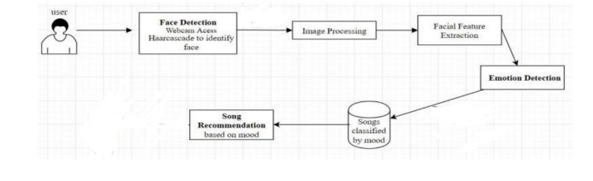

The music recommendation system features a user interface web app for user interaction. The Facial Emotion Detection App captures facial expressions using a device's camera and an Emotion Recognition Algorithm to determine the user's emotional state. Emotion Recognition and Analysis process facial data, identifying emotions. The Music Recommendation Engine suggests music based on facial emotion analysis and, suggest the user with the latest songs based on emotions which the user is having at that moment of time.

DATA FLOW

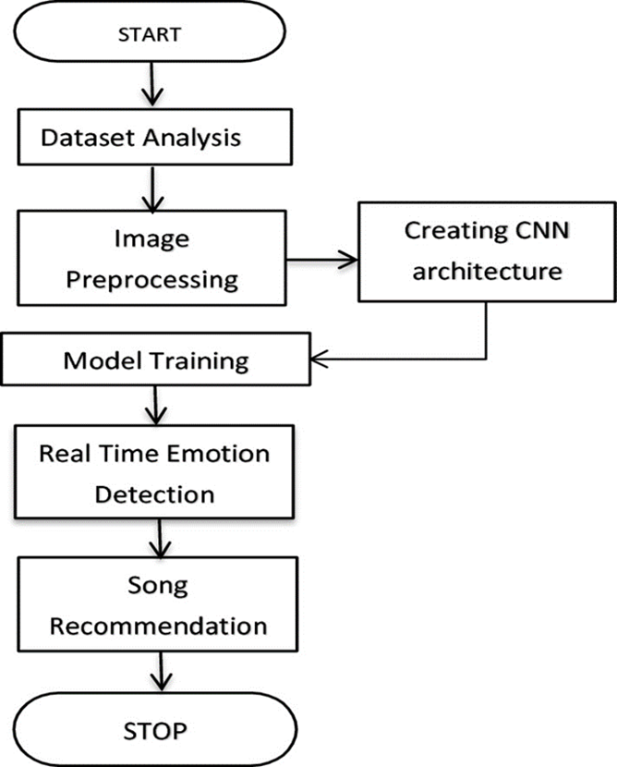

The data flow within the music recommendation illustrates a well-organized process that ensures accurate detection of emotions from Real-time images to recommending the song. Through Face detection using CNN, initiate the sequence. These queries are then directed to the Facial features extraction. which requests the necessary image to detect the emotion, to generate precise Music recommendations. Once formulated, the songs database updates the songs with the latest songs in the market based on emotions. Results are then sent back through the system to the user, completing the cycle. Ensuring the integrity and traceability of the data flow.

1. REFERENCES
2. Aurobind V.Iyer,Viral Pasad, Smita R.Sankher on Emotion based mood enhancing music recommendation, International Journal of Engineering Research & Technology (IJERT), ISSN-2278-0181, Volume 6, Issue 15, 2017
3. Wang, Shu, A novel emotion-aware hybrid music recommendation method using deep neural network, February 17, 2020.
4. Mahadik, Ankita. Real-time Emotion-based Music Recommendation Using Wearable Devices 2021
5. Assuncao, Willian G., Lara SG Piccolo, and Luciana AM Zaina. Considering emotions and contextual factors in music recommendation A Surve 2017